Home

Quixxsmart Structures® represents the latest engineering advances in a highly flexible, modular system of customized components needed for the creation of task specific workstations, flow racks and parts presentation carts. Quixxsmart designs are based on simplicity, functionality and ease of assembly. We specialize in designing and building cost-effective products that can dramatically improve your manufacturing output. Please contact us for a "no obligation" assessment of your current operations. Our engineering staff will help you create a customized work environment designed for maximum efficiency and worker safety.

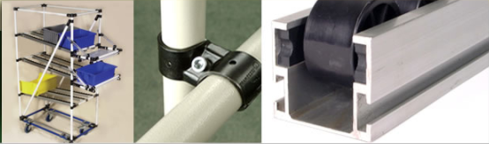

Quixxsmart Power Drive System

Your are viewing a 10 foot section alternately pushing and pulling a single pallet with a 62 pound/28.2 kg vise on it. The pallet is a simple polyethylene and MDF composite plate. The motive force of the system is a 50 watt DC gear motor driving a reinforced urethane, circular section belt. The motor is controlled by a PLC and is variable speed. Directional changes are made via proximity switches attached to brackets on the aluminum extrusion roller track. Delrin roller pullies on stainless steel axles provide long lasting quiet operation. Please contact us for your application.

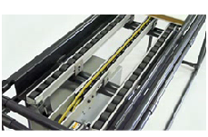

Fleximate Battery Powered Cart

We have a new concept for a self contained, powered assembly cart for larger and higher volume products. Think multiple carts in assembly cells for appliances, furniture, engines, ATVs, wave runners, transmissions, automobile instrument panels, bumper assemblies, commercial food equipment, etc.

Please ignore the background noise, the cart is as quiet as a toaster oven!



Basic Concept

The system consists of a steel cart base that has round steel guide pins mounted perpendicular at each end of the base. The system has a floor mounted UHMW PE track with a groove down the center of it. The guide pins in the cart base ride within the groove and direct the cart along the path of UHMW track. The UHMW track is fixed to the floor with double-sided foam tape. Motive power for the cart is two variable speed, 24 volt, 50 watt reduction gear motors with two deep cycle batteries for power. There is an integrated charger on each cart.

Starting, stopping, speed, fore and aft direction and duty cycle is controlled by a PLC. Positioning is achieved with photoelectric sensors mounted in the cart base that read reflector targets that are placed within the groove of the UHMW PE channel.

The carts can move fore and aft in a straight line or around an oval so positions in an assembly cell can be changed easily.

We are in the testing phase but estimate that a charge will last 10 to 12 hours.

The target payload would be 300-pounds/136 kg. This may increase.The prototype car base is 32"/812mm X 60"/1524mm; but custom sizes are available. Our working design will have the main panel and batteries situated lower and in the center of the cart.

Competition for this system would be powered belt conveyors, in floor chain elevators, and overhead monorail systems.

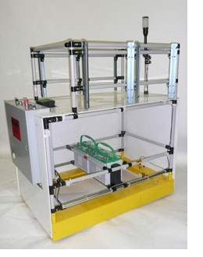

Customer Benefits

Benefits include:

Low first cost

Low installation cost: no overhead structure, no cutting floors, no rigger, no power wiring.

Guidance track is easily removed with a putty knife.

Fast installation: track is stuck to the floor with double sided adhesive tape

Low maintenance: no chains, power wiring, limited bearings. Also, the guidance channel is self lubricating.

Simple — few components to wear out

Easily reconfigured: move targets with a hex key or reprogram with the simple PLC programming.

Safe: 24-volt power, obstruction sensors and integral E-stop

Good ergonomics: 360° access to the assembly plus optional rotation and height adjustability.

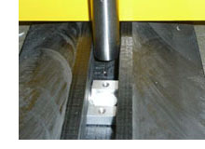

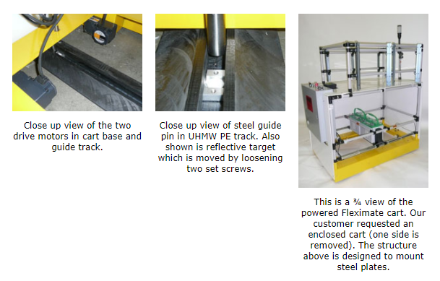

Features and Benefits

World Class manufacturing, JIT material handling, Point of use parts presentations, Lean fixturing, Quick production change-overs, Sequenced parts delivery, Continuous improvement, Improved worker ergonomics and Visual management are some of today's goals in industry. Reaching these goals should be simple, fast and cost effective. When your requirements include racks, workstations or structures, the Quixxsmart product line has your solutions.

The benefits of the Quixxsmart® Structures and racks are many:

World Class Manufacturing - Create stations and racks without welding, grinding, priming or painting with our sturdy steel tubing and fittings.

JIT Material Handling - Design flow racks for container presentation. When and where you need it.

Point of Use Parts Presentation - Quixxsmart modular design racks can be tailored for pin point parts presentation. This minimizes wasteful handling and traffic on the floor.

Lean Fixturing - Utilize Quixxsmart's sturdy steel construction and ClamptightÆ feature for accurate fixtures. This makes fixturing for low production runs feasible and cost effective.

Quick Production Changeovers - Place your custom rack on casters and change components on the fly, minimize production line downtime.

Sequenced Parts Delivery - Match your sequenced parts with your production schedule with customized racks for your subassemblies.

Continuous Improvement - Do you see a way that may improve efficiency with your racks or stations? Its easy to implement changes with a hex key and maybe some tubing or fittings. Our extreme modularity, easy adjustability and low first cost make experimentation and continuous improvement simple.

Improved Worker Ergonomics - If an optimized station or fixture or rack allows assemblers to work within their comfort zone they will not be physically taxed during their shift. The net gain is improved safety, efficiency, productivity and reduced repetitive trauma injuries.

Visual Management - Having parts presented at the point of use versus in a stock room or on a pallet in a rack allows people in a cell to easily manage their production inventory. Utilize a color on your racks to code different product component versions, models or rework.

To meet your requirements, the Quixxsmart® Structures Product is offered three ways:

Bulking Fittings, Tubing and Accessories - Order the components you need for the do it yourself products. The only tools required are a hacksaw, tube cutter, tape measure, hex key and a combination wrench.

Kit Form - Utilize Quixxsmart's CAD design capability to analyze and create equipment to your requirements. We will cut, and ship ready to assemble equipment. No cutting is required so the only tools required are hex key and combination wrench.

Set Up - We can provide the stations built and assembled to your specifications. They are shipped direct in a dedicated truck ready to use.

**Quixxstart Kits**

Much of the appeal of Quixxsmart Structures is the "Do it Yourself" Design capability for those who would like to begin a number of projects but don't know where to begin. The Quixxstart selections represent two levels of kits to help your team on the way to designing and building efficient structures, carts, racks, stations and flow racks. Fittings are complete with fasteners.

|  |  |  |  |
| --- | --- | --- | --- |
| Quixxsmart | Quixxsmart | Part | Description |
| Level 1 | Level 2 | Number |  |
|  |  |  | Fittings |
| 250 | 150 | QC-1 | Tee Fitting w/Hardware |
| 100 | 50 | QC-2 | Elbow Fitting w/Hardware |
| 100 | 50 | QC-3 | 4 Way Fitting w/Hardware |
| 100 | 50 | QC-4 | 3 Way Fitting w/Hardware |
| 100 | 50 | QC-6 | Offset Fitting w/Hardware |
| 100 | 50 | QC-6A | Cut Offset Fitting w/Hardware |
| 100 | 50 | QC-7 | Pivot Tee Fitting w/Hardware |
| 50 | 25 | QC-10 | Tee Hinge Fitting w/Hardware |
| 50 | 25 | QC-11 | Parallel Fitting w/Hardware |
| 100 | 50 | QC-13 | Universal Fitting w/ Hardware |
| 150 | 75 | QECI | End Caps |
|  |  |  |  |
|  |  |  | Roller Track and Mounting HardwareÝ |
| 100 | 50 | QF | Mounting Bracket Flow |
| 100 | 50 | QDS | Mounting Bracket Drop Stop |
| 100 | 50 | QS | Mounting Bracket Stop |
| 50 | 25 | A3MS | Aluminum Standard Roller Track |
| 24 | 12 | QSP: | Roller Track Splicer (Pair) |
|  |  |  |  |
|  |  |  | Caster and Hardware |
| 120 | 60 | QF1000Q | Upper Caster Strap |
| 120 | 60 | QF1002Q | Lower Caster Strap |
| 240 | 120 | HHCS40 | Hex Head Cap Screw |
| 24 | 12 | 74885 | 5" Total Lock Swivel Plate Caster |
| 24 | 12 | 79886 | 5" Fixed Plate Caster |
| 24 | 12 | 79885 | 5" Swivel Plate Caster |
| 24 | 12 | QLVI | 3/8" Leveler |
| 24 | 12 | QTBI | 3/8" Threaded Bushing |
|  |  |  |  |
|  |  |  | Tubing Select from the following types of tubing. |
| 100 | 50 | QJ-12 | 12' Stell Zinc Tubing |
| 100 | 50 | QP4M( ) | 4 Meter Plastic Jacket Steel Tubing |
|  |  |  | (blue, white, ivory, black, yellow or bronze) |
| 100 | 50 | QJ12PC | 12' Steel Zinc Tubing Powder Coated |
|  |  |  | (blue, white, ivory, black, yellow or bronze) |

Fittings

Our fittings are stamped from high quality steel. They are designed for maximum clamping and holding force and can be used and reused. The finish is a tough black oxide that is chip and rust resistant. For further tube retention many of the fitting bodies have 2 deep stamped ribs which help grip the tubes. This insures structural rigidity and design integrity.

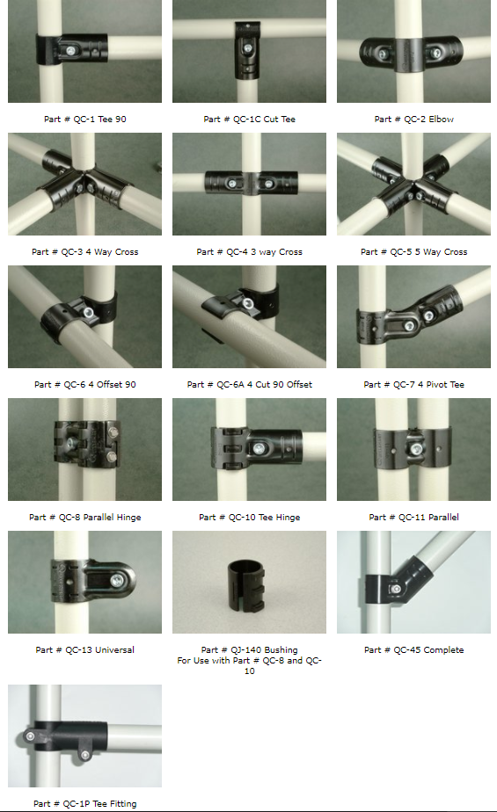

Clamptight® Make it Permanent or Semi-Permanent

Each fitting also features our patent pending Clamptight® hole design that allows you to make your rack construction semi or fully permanent (Photo 1 below). Each fitting has a 4 mm hole punched through it, providing a pilot hole to affix the fitting to a tube. For semi permanent applications the tube can be fastened with a #8 TEK (Photo 2 below) for permanent applications use a 4.2 mm drill and an Avdel #1624-D514 blind rivet (Photo 1 below). Both the self drilling fasteners, rivets and 4.2 mm bit are available from Quixxsmart. Benefits of the Clamptight® feature are:

Structural integrity for higher loads

Vibration proofing, in active load applications

Maximum tube retention for carts and tugging applications

The rivet provides a tamper proof design

Ease of application with the integral pilot hole

Can be used as a safety check to insure that the tube has been fully inserted and seated.

Clamptight® Feature

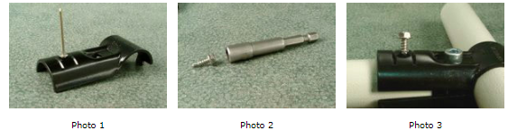

Tubing

Tubing - Steel and Plastic Coated Steel

Quixxsmart Structures Tubing is a available in 2 versions: steel with a flow coated zinc finish and steel with a bonded plastic jacket. Our zinc coated steel tubing is over double the wall thickness of competing products. The benefit is lower design and labor costs because fewer fittings and tubing are needed for a given structural requirement. The tubing is flow coated zinc for high quality appearance and corrosion resistance. It can also be powder coated in custom colors. Our thick wall tubing has a clear lacquer finish. It is specially manufactured for us and is engineered for maximum strength. Use a simple pipe cutter for clean, square cuts.

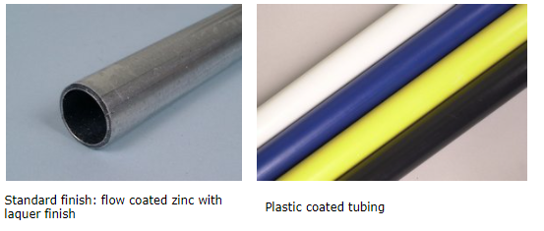

Tubing - Plastic Coated Steel Tube

A high strength steel tube with a plastic jacket is bonded on for durability. Standard length is 4 meters (13.123'). Call for color selections.

Colors = Visual Management

Utilize our plastic jacketed tubing or powder coat our steel tube to manage inventory, production changeovers, rework, safety etc. by color coding your structures and racks. Match your corporate color with a long lasting durable finish. Please call with your requirements.

With bright color coded racks and structures you can easily manage:

Inventory

Production change overs

Rework

Quality issues

Safety

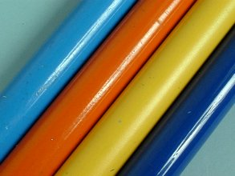

Tubing

27.5 +/- mm 1.080"

Diameter Tubing is

available in 2 finishes

1. Flow coated zinc with

lacquer coating

2. Bonded plastic jacket

over steel tube

|  |  |  |
| --- | --- | --- |
| Description | Steel Wall Thickness X Length | Part Number |
| Flow Coated Zinc | .065" / 1.6mm x 12' | QJ12 |
| Blue Plastic Jacket | .043/1.1mm x 4M | QP4MBL |
| White Plastic Jacket | .043/1.1mm x 4M | QP4MWH |
| Black Plastic Jacket | .043/1.1mm x 4M | QP4MBK |
| Ivory Plastic Jacket | .043/1.1mm x 4M | QP4MIV |
| Yellow Plastic Jacket | .043/1.1mm x 4M | QP4MYL |
| Bronze  Gray Jacket | .043/1.1mm x 4M | QP4MG |

Rollar Track

Roller Track 33mm – 44mm Diameter

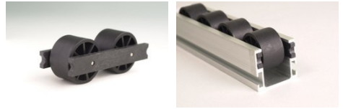

Our aluminum profile series roller track features a patent pending slide guide design to provide the most compact and efficient use of lateral space. The roller track is a 35mm high by 40 mm wide profile, with a clear anodized finish. The extrusion can be cut with a carbide blade, band saw or cold saw. A captive T-slot runs down the length of each side. With our T-slot nut P/N TSN6, guides, scanners proximity switches, light curtains and other accessories can be easily mounted and positioned on the tracks. The roller track's modular design includes two different diameter wheels, 33mm and 44 mm. The roller track can be assembled and disassembled without tools.

Roller Track — Steel Profile

Steel profile roller track in 4 meter (13.12') lengths with zinc plate finish. Solid steel axle with 33mm diameter x 25mm wide nylon roller center line spacing is 36mm. Use our standard mounting brackets with an adapter bushing.

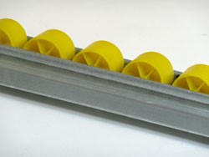

Roller Track - Steel Profile

|  |  |  |  |  |  |  |  |  |  |  |  |  |  |  |  |  |  |  |  |  |  |  |  |  |  |  |
| --- | --- | --- | --- | --- | --- | --- | --- | --- | --- | --- | --- | --- | --- | --- | --- | --- | --- | --- | --- | --- | --- | --- | --- | --- | --- | --- |
| |  |  |  |  |  |  |  |  |  |  |  |  |  |  |  |  |  |  |  |  |  |  |  |  |  |  | | --- | --- | --- | --- | --- | --- | --- | --- | --- | --- | --- | --- | --- | --- | --- | --- | --- | --- | --- | --- | --- | --- | --- | --- | --- | --- | | |  | | --- | | **Roller Track 33mm – 44mm Diameter** | | |  |  | | --- | --- | |  |  | | | Our aluminum profile series roller track features a patent pending slide guide design to provide the most compact and efficient use of lateral space. The roller track is a 35mm high by 40 mm wide profile, with a clear anodized finish. The extrusion can be cut with a carbide blade, band saw or cold saw. A captive T-slot runs down the length of each side. With our T-slot nut P/N TSN6, guides, scanners proximity switches, light curtains and other accessories can be easily mounted and positioned on the tracks. The roller track's modular design includes two different diameter wheels, 33mm and 44 mm. The roller track can be assembled and disassembled without tools. | | **Roller Track — Steel Profile**  Steel profile roller track in 4 meter (13.12') lengths with zinc plate finish. Solid steel axle with 33mm diameter x 25mm wide nylon roller center line spacing is 36mm. Use our standard mounting brackets with an adapter bushing. | | |  | | --- | | [Roller Track - Steel Profile](javascript:newWindow('images/roller-track-steel-large.html',10,10,440,340);) | | | **Slide Guide**  The optional slide guide P/N SLG is extruded from a high-density polyethylene for smooth carton glow. It is designed to provide maximum space utilization with the smallest footprint. | | |  |  | | --- | --- | |  |  | | | **Mounting Hardware**  Our mounting brackets, QS, QF, and QDS, mount the roller track to the rack frame. | | |  |  |  | | --- | --- | --- | | Part TSN6 T Slide Nut | Bracket QS | Bracket QF | | Bracket QDS | Splicer |  | | | **Power Track** | | |  |  | | --- | --- | |  |  | | |  | | |

New Power Drive System Usages

Operation: The power drive unit is designed to operate between two of Quixxsmart's roller channel. The power slide belt will be in contact with the bottom of the product or package that is being moved. The edges of the package/ product would ride on the 2 non-powered sections of roller track.

Overview: The power drive system consists of a modular conveyor contained in a Quixxsmart Structures 35 x 40 mm aluminum roller channel. Power is transmitted by a circular .250" cross section urethane belt riding in a semicircular groove on the circumference of the nylon rollers ride on polished stainless steel axles. This belt is industry proven and is field weldable.

Mounting to the conveyor legs or frame is achieved with "U" shaped mounting saddles.

Roller Track Splice: The length of the power drive system can be easily modified using QSPL splices to extend the track. Lengths of the roller channel can be cut with a carbide blade miter saw.

Usages: This system can be used for the handling of containers, for the transfer of fixtures in custom manufacturing or assembly cells or for pick cells where the power drive belt would be mounted to flow racks and move containers through order fulfillment. Please call with your specific requirements.

Electrical: Motive power is a variable speed drive fractional horse power DC gear motor driving a power drive pulley.

This brushless motor features silent operation, high torque and compact size (3" dia. and 4.5" long). The power drive motor requires a 20A 120V circuit and can be plugged into an outlet. The variable speed drive is included with the motor drive unit.

Casters

Caster Selection

Add casters to your stations and racks for flexibility and increased productivity. Casters make reconfiguring your cell fast. They also assist in clean up. There are 2 major variables when selecting casters: stem mount or plate mount as shown. Stem type are the simplest to mount on your Quixxsmart rack but are some-what limited in their weight carrying capacity. Our 3" dia 75 mm/caster is rated for 68 kg/150# per wheel. Plate type casters have heavier load capacity.

Our standard offering includes stem or plate type casters in 3"/75mm 4"/100 mm or 5"/125 mm diameter. The 4"/100 mm and 5"/125 mm casters are available with fixed, swivel and total lock rigs. The wheels are a rubber compound for quiet operation and long life. Please inquire if your caster application has additional requirements. All plate type casters have an 8mm threaded insert for fast attachment to the QF1000Q + QF1002Q caster straps with the 8 mm 30mm hex head cap screw.

|  |  |  |  |  |
| --- | --- | --- | --- | --- |
| 74885 125mm/5" swivel total lock | 79885 125mm/5" swivel | 79886 125mm/5" fixed | 515317 75mm/4" stem mount swivel | 525317 75mm/3" stem mount total lock |
| left to right: 74449, 100mm/4" total lock swivel 73449, 100mm/4" fixed 72449, 100mm/4" swivel | | | | |

See our selection guide. We offer resilient (rubber compound) as our standard wheel. Please call for specialized sizes., bearings or applications.

**Caster Mounting**

|  |  |  |
| --- | --- | --- |
| Partial View Plate Type Caster Mount | Top Strap QF1000Q | Bottom Strap QF1002Q |

Levelers / Feet

Mounting Accessories

End Cap

This piece wedges into a tube and can be used to terminate any open tubes or used as a foot. Part number QECI.

Threaded Bushing

Use the threaded bushing in conjunction with the leveler to compensate for uneven floors. Threaded bushing utilizes spring steel washers to hold on the interior tube wall and has a 3/8–16 threaded insert. Part number QTBI.

Leveler

The leveler has 3/8-16 stem and black nylon pad. Weight capacity is 150#. Part number QLVI.

|  |  |  |
| --- | --- | --- |
| [QECI - End Cap](javascript:newWindow('images/QECI-end-cap.html',10,10,490,340);) QECI - End Cap | [QTBI - Threaded Bushing](javascript:newWindow('images/QTBI-threaded-bushing.html',10,10,490,340);) QTBI - Threaded Bushing | [QLVI - Leveler](javascript:newWindow('images/QLVI-leveler.html',10,10,490,340);) QLVI - Leveler |

Levelers/Feet

Foot Jacks

Use with swivel casters for positive position. Select for 100 mm (4") or 125 mm (5") plate casters. Mounts with 2 QF1000Q and 2 QF1002Q Caster Straps. Part numbers QFJ 100 / QFJ 125.

Rubber Foot

Non-marking and slip resistant compound 1.5" diameter and 1.5" overall length. Part number QRF.

Stanchion Base

QSB Stanchion Base allows mounting of a tube in a verticle position. Tube is held in place with a set screw. Base is 3.5"/89mm diameter. Part number QSB.

Heavy Duty Leveler

16 mm thread with open slot for anchoring. Mounts with QT16 bushing. Part number QL16.

Heavy Duty Bushing

Aluminum bushing for steel or plastic jacketed tube. Mates with QL16 HD leveler. Part number QT16.

Medium Duty Leveler

Leveler 63mm/2.5" diameter nylon pad. Mounts with QTBI bushing. Part number QTB2.

Leveler Tube

(Plastic jacket tube only) Combination thermoplastic insert with metal threads and a 1.75"/44.5mm diameter leveler. Foot pad has a hard rubber insert. 11mm leveler stud with lock/adjusting nut. Part number LPTL.

|  |  |  |  |
| --- | --- | --- | --- |
| |  |  |  | | --- | --- | --- | | [QFJ 100 / QFJ 125 - Foot Jacks](javascript:newWindow('images/QFJ100-QFJ125-foot-jacks.html',10,10,490,340);) QFJ 100 / QFJ 125 - Foot Jacks | [QRF - Rubber Foot](javascript:newWindow('images/QRF-rubber-foot.html',10,10,490,340);) QRF - Rubber Foot | [QSB - Stanchion Base](javascript:newWindow('images/QSB-stanchion-base.html',10,10,490,340);) QSB - Stanchion Base | |
| |  |  |  |  | | --- | --- | --- | --- | | [QL16 - Heavy Duty Leveler](javascript:newWindow('images/QL16-heavy-leveler.html',10,10,340,340);) QL16 - Heavy Duty Leveler | [QT16 - Heavy Duty Bushing](javascript:newWindow('images/QT16-heavy-bushing.html',10,10,340,340);) QT16 - Heavy Duty Bushing | [QTB2 - Medium Duty Leveler](javascript:newWindow('images/QTB2-medium-leveler.html',10,10,340,340);) QTB2 - Medium Duty Leveler | [LPTL - Leveler Tube](javascript:newWindow('images/LPTL-leveler-tube.html',10,10,340,340);) LPTL - Leveler Tube | |

Accessories

Create custom stations and racks with these options.

These are just a few of the accessories in the Quixxsmart product line. Download a PDF of the catalog below for a complete accessories listing.

Bin Rail - Display your bins with the Bin Rail. Available in 2 lengths, small 22"/559 mm. oal. and large 40"/1016 mm. oal. Adjustable to minimize look and reach. Comes with all mounting hardware.

Support Bars - Use this accessory to mount tote boxes, cardboard containers, equipment, computers, or shelves. Available in medium 14"/356 mm. or large 20"/508 mm. The socket head cap screw to adjust for angle. Order in pairs.

Keyboard Support Parts - The keyboard support bar allows you to mount keyboards on your stations or racks. Order in pairs.

Document Clip - Use to hold instructions, pick lists, part/order identification or method sheets on your stations or racks.

Fluorescent Light Fixture - Our 120 volt fluorescent fixture will mount 1-48"/1219 mm - 40 watt fluorescent lamps. Comes with off/on switch, a 6/1829 mm. 3 wire cord, all mounting hardware, and a snap in lens.

Status Light - Use the status light to visually manage stock outs, quality, and production. 3 lights with a 3 position selector switch and a 6/1829 mm.-3 wire cord, includes mounting hardware. 120 volt.

Outlet Strip - A receptacle power strip comes with all mounting hardware, a lighted on/off switch, 4 receptacles, resetable thermal overload, 6/1829 mm. 3 wire cord and all mounting hardware.

|  |
| --- |
|  |
| **Even more accessories** |  |  |
|  |  |  |
| **Trailer Hitch - #QTH** Steel hitch with Pintle coupling, .25" thick steel is rated for 400 pounds both the tongue and the coupling hitch mount to parallel tubes with 2- #QF 100Q and 2 - #QF1002Q with 8 mm hex cap screws see our caster section for your cart design. Dimensions: 3" H x 13 1/2" W x 19 1/8" L |  | [[trailer hitch](javascript:newWindow('images/qth_trailer_hitch_large.jpg',10,10,400,400);)](javascript:newWindow('images/qth_trailer_hitch_large.jpg',10,10,400,400);) |
|  |  |  |
| **Hangers #QHIL and QHRA** These wire hangers provide a sturdy support to hang parts, cable assemblies, or build sheets. The hook is either in line #QHIL with the tube that it hanging on or at a right angle. #QHRA. Weight capacity is 25 pounds. Dimensions: 3.75” Long x 1.5” wide, 95mm x 38mm |  | [[hangers](javascript:newWindow('images/QHIL+QHRA_Hangers_large.jpg',10,10,400,400);)](javascript:newWindow('images/QHIL+QHRA_Hangers_large.jpg',10,10,400,400);) |
|  |  |  |
| **Vesa Mount - QVSA** Standard flat screen mount. 2 pieces for quick removal. Mount comes with 4 QC13 universal fittings for attachment on 2 horizontal tubes. Powder coat finish. |  | [qvsa vesa mount](javascript:newWindow('images/qvsa_vesa_mount_large.jpg',10,10,400,400);) |
|  |  |  |
| **House Keeping Station #QHKS** Our housekeeping station provides an area for quick storage for your station’s cleaning tools and supplies. The hook and spring loaded handle holder are designed for your brooms, dust pans and brushes. And the cut out provides a storage area for spray cans or bottles. Comes with four QC13 universal fittings for mounting on 2 parallel tubes. Dimensions: 7” H x 5” D x 6” W, 178 mm x 127 mm x152 mm |  | [qhks house keeping station](javascript:newWindow('images/qhks_house_keeping_large.jpg',10,10,400,400);) |
|  |  |  |
| **Wire Dispenser #QWP** Use to mount and dispense solder wire, wire, safety wire etc. The drop in rod design makes replenishment and change overs quick. Comes with two QC13 universal fittings for mounting on a horizontal tube. Dimensions: 3” H x 7” D x 8” W, 178 mm x 127 mm x152 mm |  | [QWP Wire Dispenser](javascript:newWindow('images/qwp_wire_dispenser_large.jpg',10,10,400,400);) |
|  |  |  |
| **Rollers** This modular roller system can be used to quickly implement line side parts presentation of tote boxes and containers. Modular design makes adding lengths as simple as pushing in a plastic expansion rivet. High impact plastic construction provides easy placement and eliminates corrosion issues. Low resistance ball bearing design insures effortless container flow. 50# capacity per roller. Dimensions 18.75” W x 4.25 Center x 2.88” High 476mm W x 108mm C x 73 mm H Roller diameter 1.88”, 48 mm |  | [rollers](javascript:newWindow('images/rollers_large.jpg',10,10,400,400);) |
|  |  |  |
| **Pneumatic Torque Tool Holder** This tool holder mounts with two wood screws to the underside of a work surface, thereby saving valuable work area space. Angled presentation design provides ergonomic tool deployment. UHMW design protects tool finish and minimizes wear. Front to back dimensions: 12" (305 mm), hole diameter 2.5” (63.5 mm) |  |  |

Custom Aplications

Design your own or have us do it. The benefit of our modular system is the ability to custom create racks, stations, carts, fixtures, etc. to your specification in the minimum amount of time. Here are some of our customers' custom creations.

Design Guide

Download this PDF file for a faxable version of the form. Download now.

If you need the free Acrobat Reader plug-in to view the PDF file, click here.

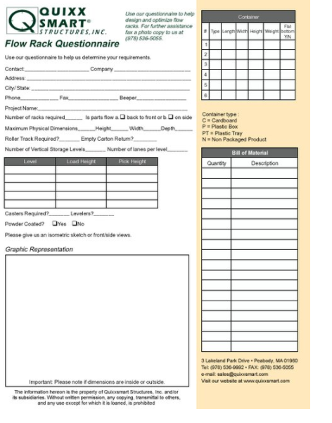

Contact Us

To have a free full-color catalog mailed to you, to request a CAD Cell Questionnaire, or to simply get in touch, use the form below.

Fields marked with * must be filled.

*Your Name:

*Company Name:

*E-mail:

*Street Address:

Mail Stop #:

City:

State/Province:

Zip/Postal Code:

Country:

*Phone:

Fax:

Product Interest:

Workstations

New Products

Carts

Flow Racks

Parts Presentation

Comments:

Receive our catalog by mail.

Yes

No

Continue to receive updates

Yes

No